Asia-China-Mirror-Jade Inlaid-

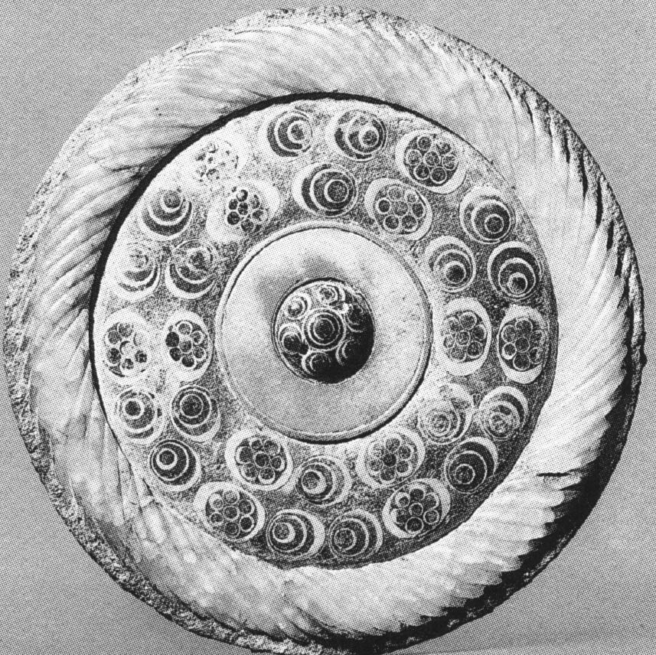

The inlaid jade Liuli Chung  
Saddle round  
Helpless twelve • two centimeters Fu Luo Institute Golden Village unearthed  
Blue the Liuli button 'with a white ferrule grabbing a girl, Block jade flaw. Outer ferrule relative wide blue colored glaze embedded six white flower-shaped public opinion. Mirror marry the case of of Xuxu Syria jade flaw. This mirror work exposing special 'colors the color target Cave' is rather a precious